**KAMPALA URBAN SCHOOLS**

**BEGINNING OF FEBRUARY EXAMINATIONS, 2024**

**PRIMARY FIVE SCIENCE**

**NAME:_________________________________________STREAM: _____**

SECTION A: 40MARKS

1. What does an insect use to breathe in and out?

__________________________________________________________

2. In which part of a sweet potato plant is food for the plant stored?

__________________________________________________________

3. State one advantage of brushing teeth after meal.

__________________________________________________________

4. Apart from beans, give one other example of a crop that is a legume.

__________________________________________________________

5. Give one reason why people keep rabbits.

__________________________________________________________

***The diagram below shows a method of planting maize grains. Study it carefully and answer question 6*.**

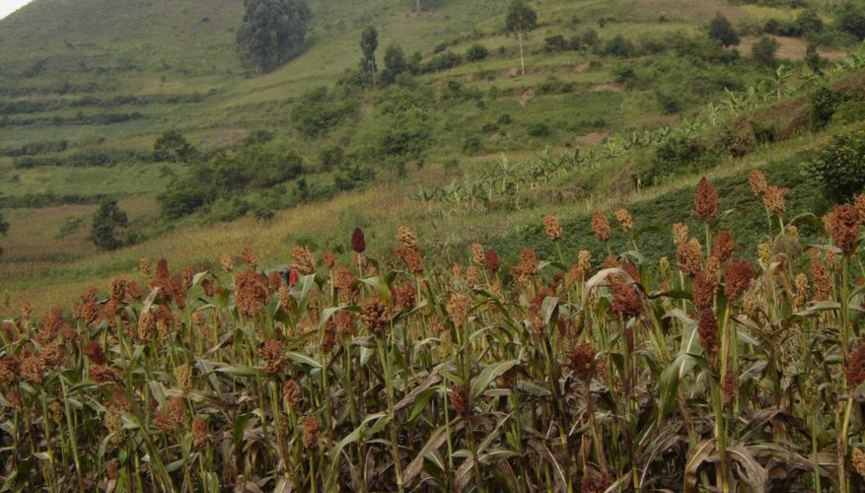

6. What is the method of sowing seeds shown in the diagram above?

__________________________________________________________

8. Where in the digestive system of man are proteins first digested?

__________________________________________________________

9. In the space below, draw a simple diagram of a tap root system.

10. Name the gas used in fire extinguisher.

____________________________________________________________

11. State the eye disease which is spread by houseflies.

____________________________________________________________

12. Which part of a fish does the similar function as the human ear?

____________________________________________________________

13. What is the use of a rain gauge at a Weather Station?

____________________________________________________________

14. Which intestinal worm enters the human body through bare feet?

____________________________________________________________

15. What is the danger of too much wax in the human ear?

_____________________________________________________________

16. Give one way in which maggots in pit latrines are useful.

____________________________________________________________

17. Mention any one good health habit that can improve the working of

the lungs and the heart.

____________________________________________________________

18. Which organs are used by both fish and tadpoles for breathing?

____________________________________________________________

19. Apart from eating a balanced diet, give any one other way of

controlling common diseases at home.

____________________________________________________________

20. Which part of a maize grain has a similar function as the cotyledon of

a bean seed?

____________________________________________________________

21. State one way in which tsetse flies may be dangerous to humans.

____________________________________________________________

22. State one use of soil to man.

____________________________________________________________

23. Name one example of annual crop.

____________________________________________________________

24. What is a hutch in rabbit keeping?

____________________________________________________________

25. Give any one use of food in the body.

____________________________________________________________

26. Name any one disease of teeth in man.

____________________________________________________________

27. Identify one component of a first aid kit.

____________________________________________________________

28. Which part of sugarcane plant is eaten as food by people?

_____________________________________________________________

Use the diagram below to answer question 29

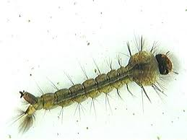

29. Name the stage in the life cycle of a mosquito shown above.

____________________________________________________________

30. State one importance of sunny weather to people.

____________________________________________________________

31. What is the importance of pruning crops?

____________________________________________________________

32. How are forests and bushes important to wild animals?

____________________________________________________________

33. Name the garden tool used for digging in a tomato garden.

____________________________________________________________

34. Mention one childhood immunisable disease.

____________________________________________________________

35. Which term refers to tiny organisms that cause diseases?

____________________________________________________________

36. State one use of water at home.

____________________________________________________________

37. Why is it dangerous to dispose faeces in the bushes?

____________________________________________________________

38. Name any one layer of a soil profile.

____________________________________________________________

39. Which body organ interprets the sound we hear?

____________________________________________________________

40. Write the property of air that helps a person to suck juice using a

straw from a bottle as shown below.

______________________________________________________________

**SECTION B**

41. (a) State any two ways in which vectors spread diseases to humans.

(i)_____________________________________________________________

(ii)____________________________________________________________

(b) Give any two ways of preventing vectors from spreading diseases to humans

(i)____________________________________________________________

(ii)____________________________________________________________

42. The diagram below is of the human urinary system. Study and use it to answer the questions that follow.

W

M

B

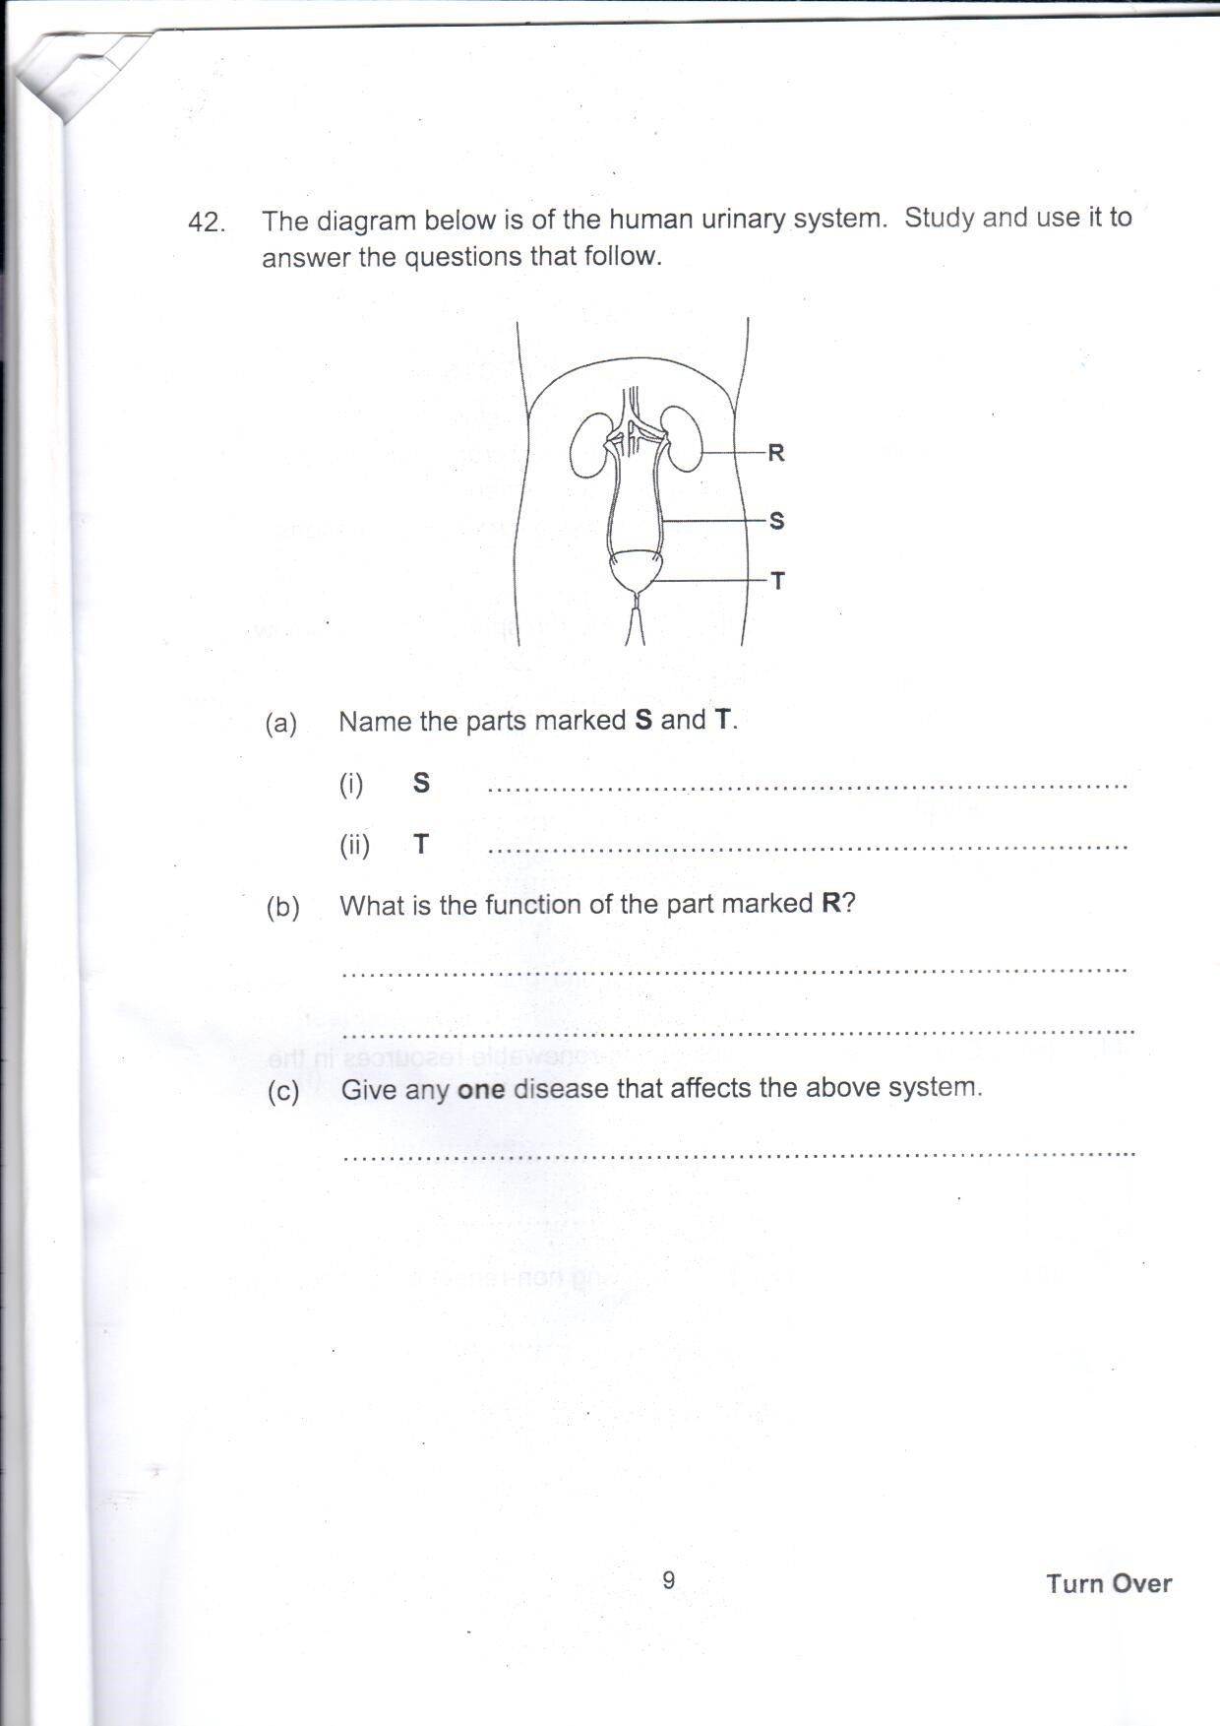

1. Name the parts marked by letters B, M and W
2. B_________________________________________________
3. M_________________________________________________
4. W_________________________________________________
5. What is the function of part B?

_____________________________________________________

43. (a) Write two components of soil

(i) ____________________________________________________

(ii) ___________________________________________________________

1. What is soil profile? ________________________________________

__________________________________________________________

(c) Give one way of maintaining moisture (water) in the soil.

__________________________________________________________

__________________________________________________________

44. The diagram below shows a section through a human tooth.

Study and use it to answer the questions that follow.

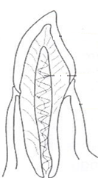

1. Name the type of teeth shown above.

________________________________________________________

1. Identify two sets of teeth that develops in man.

(i)________________________(ii)____________________________

1. Which is the hardest part of a tooth?

________________________________________________________

45. (a) What are intestinal worms?

___________________________________________________________

___________________________________________________________

(b) Write the intestinal worm that enters our body when you

eat undercooked or raw meat.

______________________________________________________________

(c) The diagram below is of an intestinal worm.

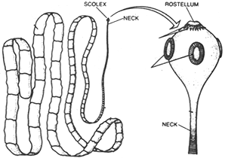

**y**

**x**

Name the parts marked by letter

x___________________________ y_______________________________

46. Match the following garden tools to their uses

**Garden tool Uses**

1. Trowel for cutting small branches.
2. Sickle for transplanting
3. Knap Sack sprayer for harvesting cereal
4. Panga for spraying herbicides
5. Panga ____________________________________________
6. Knap Sack sprayer_________________________________________
7. Sickle ____________________________________________
8. Trowel ____________________________________________

47. (a) What name is given to plants that bear flowers?

__________________________________________________________

(b) Name two systems on a flowering plant.

(i) ___________________________ (ii)___________________________

(c) Apart from wind, name one other agent of pollination.

__________________________________________________________

48. Write the following short forms (abbreviations) in full as used

in Science.

1. ORS_______________________________________________
2. SSS_______________________________________________
3. 3Gs_______________________________________________
4. CDD_______________________________________________

49. (a) Name two living things that live in the soil.

(i) _________________________(ii)________________________

(b) What is a habitat?

_____________________________________________________

(c) Why do people plant trees in their compounds?

_____________________________________________________

50. (a) What are communicable diseases?

_____________________________________________________

_____________________________________________________

1. Identify two communicable diseases got through drinking

unboiled water.

(i) _________________________(ii)________________________

(c) Write one example of a non-infectious disease in children.

_____________________________________________________

51.(a) Wind is moving air. Mention two components of air that occupies the following percentages in the atmosphere.

(i)1%________________________(ii)0.03%_________________________

(b) Which component of air occupies the largest percentage in the atmosphere? ____________________________________________________________

(c) State one game played using air.

__________________________________________________________

52. (a) What are domestic animals?

__________________________________________________________

(b) Give one danger of sharing a house with domestic animals.

___________________________________________________________

(c) Write down two examples of domestic animals kept for meat.

(i) _________________________(ii)_____________________________

53. (a) Which type of family has mother, father and their biological children?

___________________________________________________________

(b) Write the responsibility of each of the following member of a

nuclear family.

(i) Mother______________________________________________________

(ii)Father______________________________________________________

(iii) Children____________________________________________________

1. Give one problem that can be faced by a family with very

many members.

___________________________________________________________

54. Complete the table correctly

|  |  |  |
| --- | --- | --- |
|  | **Vectors** | **Diseases** |
|  | Fleas | Bubonic plague |
| (i) | Water snails | _______________________ |
| (ii) | ___________________ | Malaria |
| (iii) | Culex mosquitoes | _______________________ |
| (iv) | ___________________ | Relapsing fever |

55. The diagram below is of a leaf. Use it to answer the questions that follow.

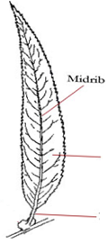

N

Y

1. Name the parts marked by letter N and Y

N_______________________________________________________

Y_______________________________________________________

1. Apart from breathing, give one other function of leaves to a plant.

________________________________________________________________________________________________________________

1. How is the chlorophyll on the leaf important to a plant

________________________________________________________________________________________________________________

**Thank you &Good Luck**